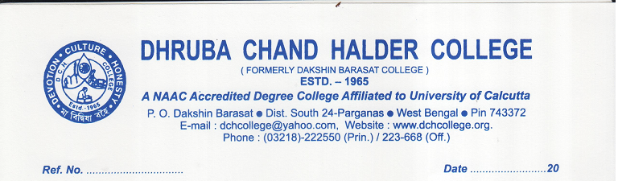
02.07.2021
NOTIFICATIONS

The Government of West Bengal has launched “West Bengal Student Credit Card Scheme (WBSCCS)” to help the aspirant students of West Bengal in pursuing higher study without facing financial constraints. The students pursuing education from class 10 onwards or studying various courses and/or in coaching institutes for appearing in different competitive examinations like Engineering/Medical/Law, IAS, IPS, WBCS, SSC etc., UPSC, PSC, SSC etc., and pursuing Undergraduate, Postgraduate courses including professional degree, Diploma courses and research at doctoral (Ph.D.)/post-doctoral (PDF) level or similar courses upto age of 40 years are eligible to avail the scheme. To get the details of the scheme the interested students may visit https://wbscc.wb.gov.in or call to the toll free number 1800-102-80-14.

